***5. PLC Procedure to Run the Program***

**5.1 Procedure to Connect the PLC Processor with programming PC**

1. We need to Install Rockwell Software packages, Which has Rslogix500, Rslinx classic in it.
2. After the installation, we need to connect the PLC Processor with the Programming PC via Ethernet. For that, the internet properties should changed, the IP address of the SLC 5/03 processor should be dialed to establish the connection.
3. If it is connected, Rslinx classic will show the connected processor. We can check this by checking RSwho tab in the Rslinx Classic’s window.

**5.2 Procedure to Run the Motor in Different Speed**

1. We need to develop the Ladder Logic to Control the speed of motor in forward and reverse direction.
2. For that, When the Recipe Selector switch is “ON”, we need to select the Forward or Reverse Push Button.
3. When the Forward Push Button(I:1.1) is ON the Binary Bit B3:0.0 is Set, Since it is the latched OutPut the Bit will be set unless it is unlatched.
4. Once B3:0.0 is set, It will Turn ON the Forward Indication Light (O:1.0 is Set) and start the motor in forward direction(O:2.1 is set) .
5. For the Reverse direction rotation of Motor the Push Button Input bit I:1.2 is set .
6. When I:1.2 is set, that will latch the Reverse Binary bit B3:0.1 and unlatch the B3:0.0(Which is used for Forward Bit).When B3:0.1 is latched, Output bit 0:1.1 & 0:2.2 is set for Reverse indication Light and Reverse Direction of Motor.The Motor will start rotating in Reverse direction.
7. For the Low Speed, we have selected the Input Bit (I:1.3), when it is set , It will latch the output O:1.2 for Indication Light and O:2.3 for the Motor Low Speed. The motor will run in Low Speed in Forward/Reverse Direction. The frequency set for Low Speed is 30 Hz in the Mitshubishi VFD. The rpm from the Motor is 896 rpm for Low Speed.

When the bit I:1.3 is set, It also unlatches the Output Bits O:2.4,O:2.5,O:1.3 and O:1.4, Which are the output bits designated for Medium Speed, High Speed , Medium Speed Indication Light and High Speed indication Light in the output data files.

1. For the medium speed, Input Bit I:1.4 is set , the latched output bit O:2.4 is set for medium speed of motor and latched output bit O:1.3 is also set for Medium speed indication light. The Motor runs in medium speed in forward/Reverse direction. The frequency set for medium speed is 40 HZ in the VFD. The rpm from the motor is 1188 rpm for medium speed.

When the bit I:1.4 is set, It also unlatches the Output Bits O:2.3,O:2.5,O:1.2 and O:1.4, Which are the output bits designated for Low Speed, High Speed , Low Speed Indication Light and High Speed indication Light in the output data files.

1. For the high speed, Input Bit I:1.5 is set , the latched output bit O:2.5 is set for high speed of motor and latched output bit O:1.4 is also set for High speed indication light. The Motor runs in High speed in forward/reverse direction. The frequency set for high speed is 60 HZ in the VFD. The rpm from the motor is 1750 rpm for high speed.

When the bit I:1.5 is set, It also unlatches the Output Bits O:2.3,O:2.4,O:1.2 and O:1.3, Which are the output bits designated for Low Speed, Medium Speed , Low Speed Indication Light and Medium Speed indication Light in the output data files.

1. To Stop the process or for Emergency stop, We have STOP Push Button. It is an input bit I:2.0. when I:2.0 is set, it will unlatch the Forward bit B3:0.0, Reverse bit B3:0.1 and all other output bits given for different speed and speed indication.
2. Scaled with Parameters (SCP) has been used in the last rung in the program to measure the speed of the motor from the speed sensor (I:3.0) attached with the AC motor. I:3.0 is an analog input bit, So whenever the motor is rotating the bit will get the value, ranging from 0 – 19275. This value has been scaled with the motor rated value of 1750 rpm at 60Hz and 0 rpm at 0 HZ.
3. After the PLC program is Successfully created, we need to download the program into PLC. For that we need to put the Key Switch in PROG and Select Download.
4. To Run the program, we need to toggle the switch into RUN mode in SLC 5/03 processor, and it is ready to run.

**5.3 Tools Used:**

1. Allen Bradly SLC 5/03 Processor

2. Mitshubishi FR-S500 VFD

3. AC Motor ( 60Hz – 1750 rpm)

4. Rslogix 500 PLC Program

5. Rslinx Classic

**5.4 Pictures**

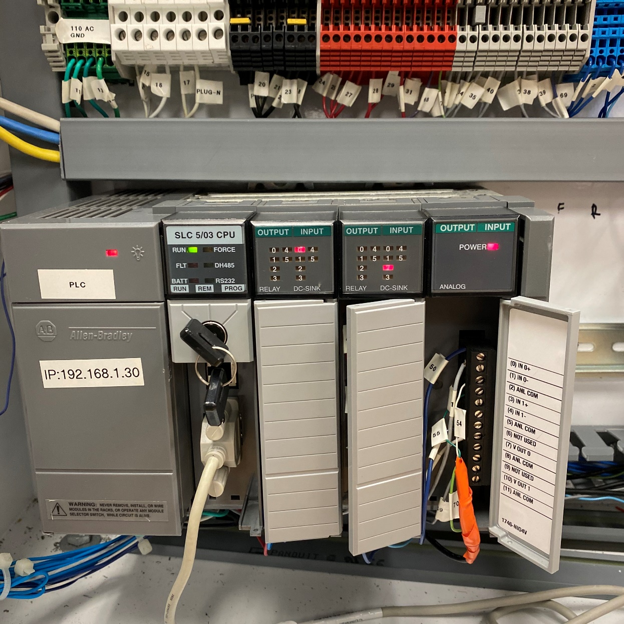

**Fig : Allen Bradly SLC 5/03 Processor**

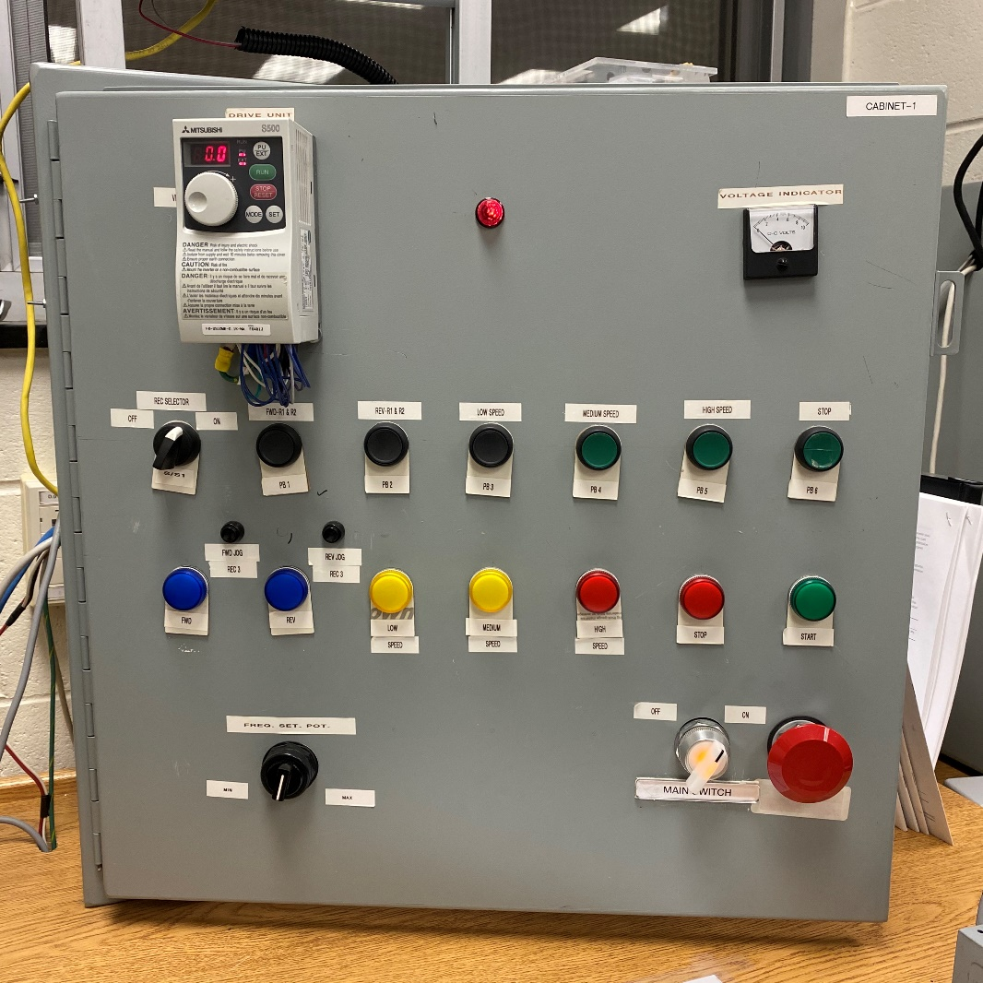

**Fig : Speed control Panel with VFD**

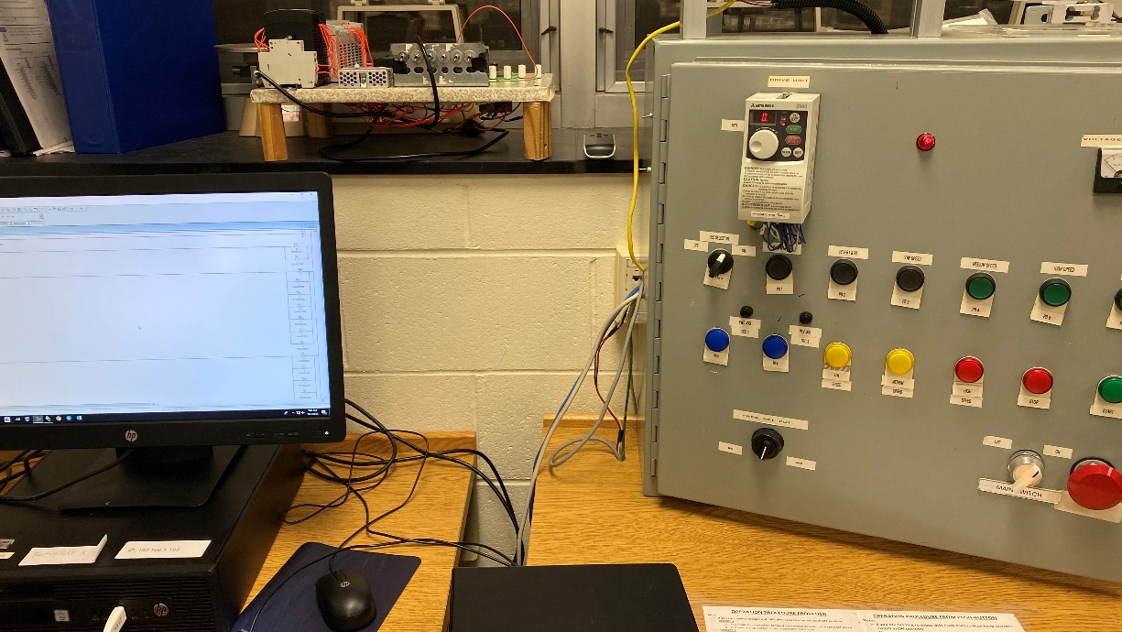

**Fig: Programming PC and VFD Control panel connected via Ethernet.**

***6. Conclusion***

Thus, Human machine interface has been set up and the speed control of AC Motor has been achieved by using Variable Frequency drive. Rslogix 500 and Rslinx classic is the software part and the VFD, Processor and the AC Motor is the hardware part in this project. The Speed of the motor at different frequencies has been listed in the table below.

|  |  |  |
| --- | --- | --- |
| Frequency (Hz) | Motor Speed (rpm) | |
| Forward Direction | Reverse Direction |
| 30  40  60 | 896  1188  1750 | 896  1188  1750 |